* **Basic List**

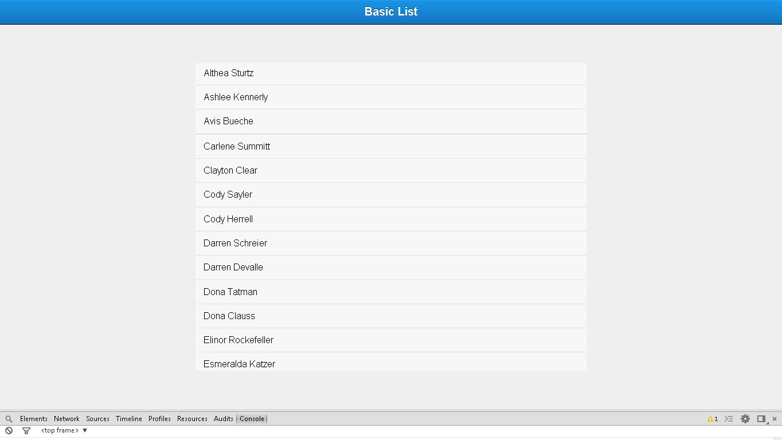

**Snapshot 1.1**

**Code**

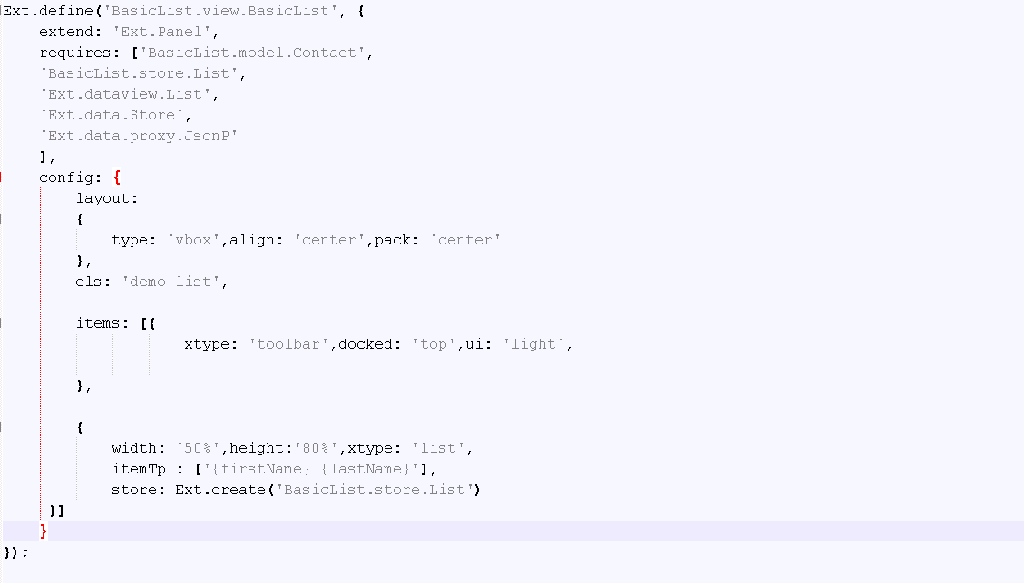

**Snapshot 1.2**

**Ext.define('BasicList.view.BasicList',** :->User defined class BasicList is defined

**{**

**extend: 'Ext.Panel',** :-> Extneds to Panel(Super class to use in your application)

**requires: ['BasicList.model.Contact',** :-> Contact model class is required here which is defined in model folder of BasicList application

**'BasicList.store.List',** :-> List store class is required here which is defined in store folder of BasicList application to add data in list

**'Ext.dataview.List',** :-> inbuilt List class is required to use list in your application

**'Ext.data.Store',** :-> inbuilt Store class is required to use store in your application

**'Ext.data.proxy.JsonP'** :-> inbuilt JsonPclass is required to use proxy connection in your application

**],**

**config: {**

**layout:** :-> Layout is defined for List

**{**

**type: 'vbox',align: 'center',pack: 'center'**

**},**

**cls: 'demo-list',**

**items: [{**

**xtype: 'toolbar',docked: 'top',ui: 'light',**

**},**

**{**

**width: '50%',height:'80%',xtype: 'list',**

**itemTpl: ['{firstName} {lastName}'],** :-> List structure is defined

**store: Ext.create('BasicList.store.List')** :-> store is defined here to use in your application.

**}]**

**}**

**});**

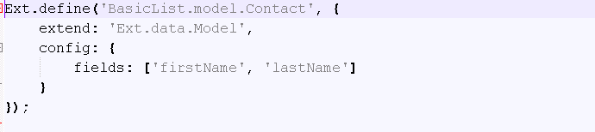

**Snapshot 1.3**

**Ext.define('BasicList.model.Contact',** :-> User defined Contact model class is defined

**{**

**extend: 'Ext.data.Model',** :-> Model super class is extended, which is required to define model

**config: {**

**fields: ['firstName', 'lastName'] :**-> Field structure is defined

**}**

**});**

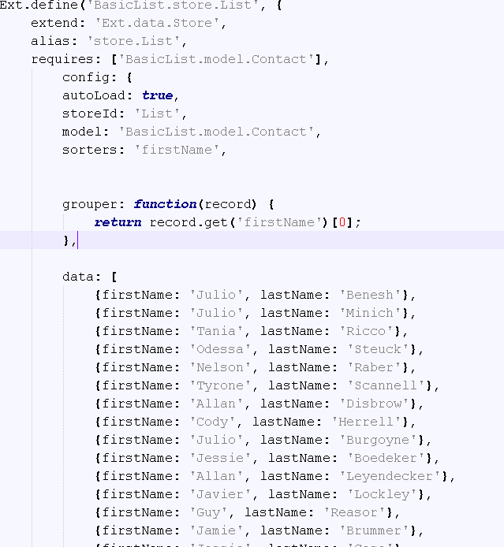

**Snapshot 1.4**

**Ext.define('BasicList.store.List',** :-> User defined store class is defined

**{**

**extend: 'Ext.data.Store',** :-> Super class store is extended which is required to use store

**alias: 'store.List',**

**requires: ['BasicList.model.Contact'],** :-> Store requires model class to use its field’s structure

**config: {**

**autoLoad: true,** :-> To load list automatically

**storeId: 'List',** :-> store id is defined

**model: 'BasicList.model.Contact',**

**sorters: 'firstName',** :-> sorter property is used to sort list according to firstName

**grouper: function(record) {**

**return record.get('firstName')[0];** :-> Function to return list according to firstName

**},**

**data: [**

**{firstName: 'Julio', lastName: 'Benesh'},** :-> Datalist to include in list

**FAQ**

1. Why **itemTpl** is used?

Ans: itemTpl is item template used to define basic structure.

**Checkpoints:**

1. Check carefully with your indentations as if you will miss any of the braces by mistake may reflect in compilation error.
2. See that your .js file starts with Ext.Define block and check that ends at the end of the program.
3. More than one items are separated by comma (,) separator and main program block of define is ended by semi colon (;)
4. Any value is assigned using colon (:) for example ui: 'confirm' and value is written inside single coats.
5. Items block starts with square brackets [] , which contains multiple members and also sub items.
6. Don’t forget to add entries of your files in app.js

**Source Code:**

